# AZ-400 DevOps Glossary Project - DevOps Implementation Summary

## 1. Project Setup

We started with a simple JavaScript-based DevOps Glossary app. The app was structured inside the 'project_repo' folder and included an index.html, style.css, script.js, and glossary.json.

The project was versioned using Git and pushed to GitHub.

## 2. Deployment

We deployed the app to two environments:  
- GitHub Pages for development environment.  
- Vercel for the production environment.

GitHub Pages Link:  
https://profadityasaxena.github.io/AZ400_ExamPrep_A_Project_Based_Course/project_repo/

Vercel Production Link:  
https://az-400-exam-prep-a-project-based-course.vercel.app

## 3. CI Workflow Integration

We implemented a GitHub Actions workflow (ci.yml) that validates:  
- HTML using HTMLHint  
- JavaScript syntax using 'node -c'  
This CI pipeline runs on every push or pull request to the main branch.

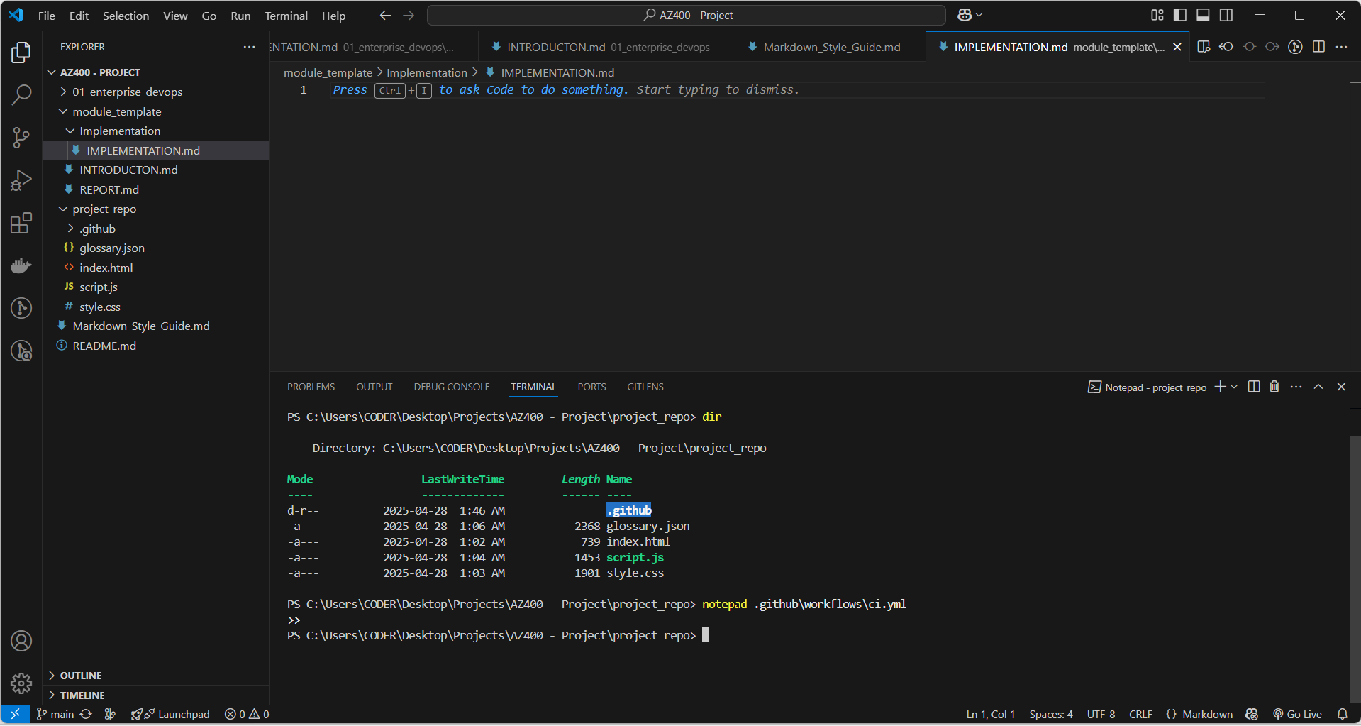

↑ Workflow folder creation in VS Code

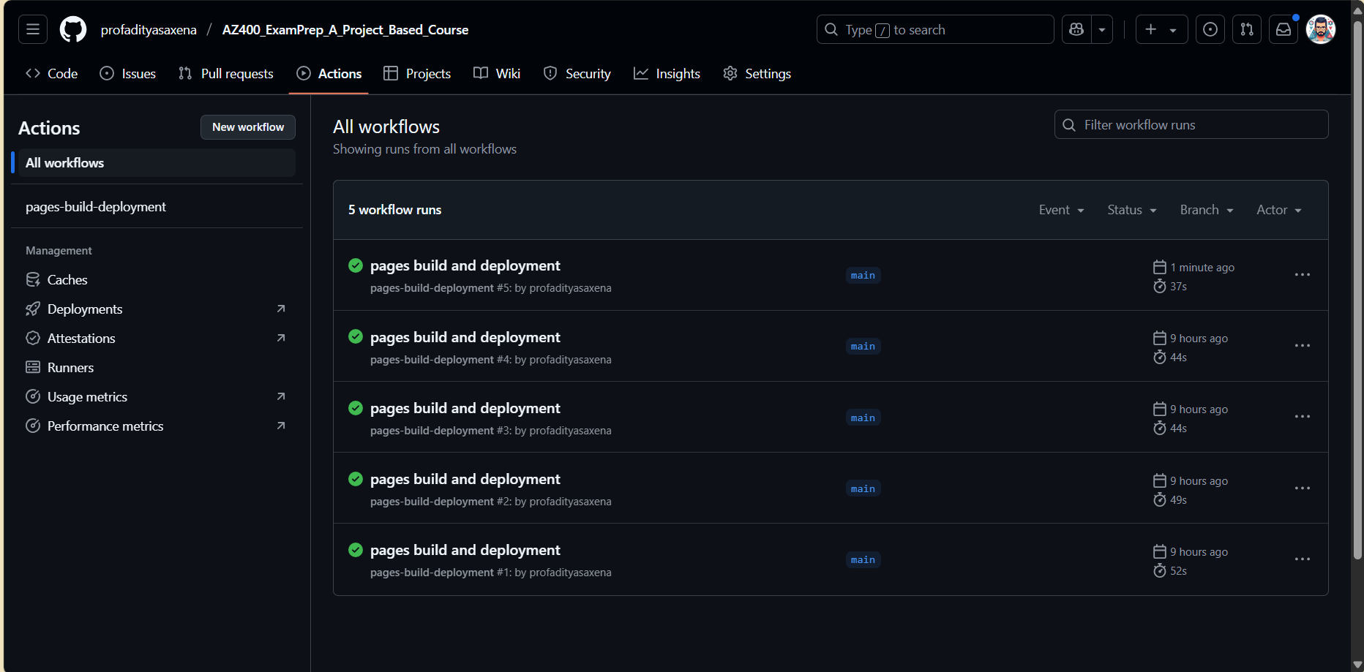

↑ GitHub Actions dashboard showing CI pipeline runs

## 4. Vercel Deployment

The application was also deployed to Vercel as the production environment.

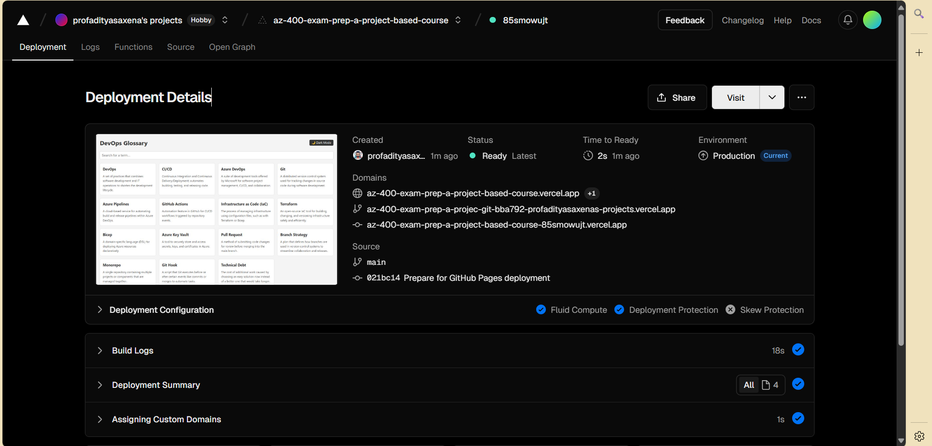

↑ Vercel deployment details showing production status